MACHINE LEARNING
Machine Learning is a branch of artificial Intelligence.
Machine Learning focuses on developing models and algorithm that let computer learn from the data without being explicitly programmed.
Machine Learning is mainly divided into 3 core types:
- Supervised Learning: trains model on labeled data to predict or classify new or unseen data.
- UnSupervised Learning: Find patterns or groups in unlabeled data.
- Reinforcement Learning: Learns through trial and error to maximize rewards ideal for decision making tasks.
Additional types:
- Self-Supervised Learning: it generates its own labels from the data without any manual labeling. It is used in training large-scale models.
- Semi-Supervised Learning: this combines a small amount of labeled data with large amount of unlabeled data.
MACHINE LEARNING PIPELINE
Data Preprocessing – Exploratory Data Analysis – Model Evaluation.
- Data Cleaning  - Data Preprocessing  Using python  - Feature Scaling  - Feature Extraction  - Feature Engineering  - Feature Selection  Techniques. | - Exploratory Data Analysis  - Exploratory Data Analysis in Python  - Advance EDA  - Time Series Data Visualization. | - Regulation in Machine Learning  - Confusion Matrix  - Precision, Recall and F-1 Score  - AUC – ROC Curve  - Cross – Validation  - Hyperparameter Tuning

SUPERVISED MACHINE LEARNING
Classified into two main categories:
- Classification: goal is to predict discrete labels or categories.
- Regression: where the aim is to predict continuous numerical values.
Commonly used supervised learning algorithms are:
- Linear Regression: this is simplest way to predict numbers using a straight line. It helps find relationship between input and output.
- Logistic Regression: used when the output is yes or no type. It helps in predicting categories like pass/fail or spam/not spam.
- Decision Tree: A model that makes decisions by asking a series of simple questions.
- Support Vector Machine: A bit more advance – it tries to draw the best line to separate different categories of data.

LINEAR REGRESSION
It is a fundamental supervised learning algorithm used to model the relationship between a dependent variable and one or more independent variable.
It predicts continuous values by fitting a straight line that best represents the data by minimizing prediction errors (least square method).
It assumes that there is a linear relationship between the input and output.
Commonly used in forecasting, trend analysis, medical risk prediction and predictive modelling.
Types of Linear Regression:
- Simple Linear Regression: predicts the dependent variable using a single independent variable.
- Multiple Linear Regression: use two or more independent variables to predict the dependent variable.
Challenges in Linear Regression:
- Overfitting
- Multicollinearity
- Assumptions of Linearity
- Sensitive to outliers
Linear Regression uses the independent variable to predict the dependent variable.
Best Fit Line:
In linear regression, it is the straight line that best represents the relationship between the independent variable(input) and the dependent variable(output).
The goal is to minimize the difference between the actual data points and the predicted value generated by the model.
This lines helps to predict the dependent variable for new, unseen data.
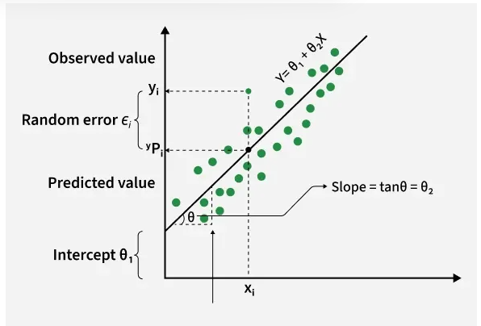
In this diagram:
Y is called a dependent or target variable.
X is called independent variable or predictor of Y.
θ1 represent the intercept, which is the value of Y when X = 0.
θ2 represent the slope, which shows how much Y change for a unit change in X.

Equation for the best fit line with one independent variable: y = mx + b, where y is the predicted value, x is the input, m is the slope of the line and b is the intercept.
The Best fit line will be the one that optimizes the value of m and b so the predicted y values are as close as possible to the actual data points.
Minimizing the Error using the Least Square Method:
It minimizes the difference between actual and predicted value. These differences are called residuals.
Formula for residuals is: yᵢ−y^​ᵢ
Where, yᵢ is the actual observed value and y^​ᵢ is the predicted value from the line for the xᵢ.
The least square method minimizes the sum of the squared residuals: Σ(yᵢ−y^​ᵢ) ².
This method ensures that the line best represents the data where the sum of the squared differences between the predicted values and actual values is as small as possible.
Slope: it indicates how much the dependent variable changes for every one-unit increase in the independent variable. Ex: if slope is 5, y will increase by 5 units for every 1-unit increase.
Intercept: it represents the predicted value of y when x = 0. It’s the point where the line crosses the y-axis.
Limitations:
- Assumes Linearity: this method assumes the relationship between the variable is linear. If the relationship is non-linear, linear regression might not work well.
- Sensitivity to outliers: outliers can significantly affect the slope and intercept, skewing the best-fit line.
In Linear regression some hypothesis is made to ensure reliability of the model’s results.
Hypothesis Function:
It is an equation used to make predictions about dependent variable based on independent variable. It represents the relationship between the input features and the target output.
For one independent variable hypothesis function is: h(x)=β₀+β₁x
Where: h(x) or (y^) is the predicted value of the dependent variable (y), X is the independent variable, β₀ is the intercept and β₁ is the slope.
For multiple linear regression the hypothesis function expands to: h(x₁,x₂,...,xₖ)=β₀+β₁x₁+β₂x₂+...+βₖxₖ
Where: x₁,x₂,...,xₖ are the independent variables, β₀ is the intercept, β₁,β₂,...,βₖ are the coefficients representing the influence of each respective independent variable on the predicted output.
Cost Function:
It measures how far the predicted values Y^ are from the actual value (Y). It helps identify and reduce errors to find the best fine fit line.
The most common cost function used is Mean Squared Error(MSE) which calculates the average of squared differences between actual and predicted values.
Cost function(J) = n1​∑ni​(yi​^​−yi​)2
Here, yi​^​=θ1​+θ2​xi: it is used to minimize this cost, we use Gradient Descent, which iteratively updates θ₁ and θ₂ until the MSE reaches its lowest value. This ensures the line fits the data as accurately as possible.
Gradient Descent:
It is an optimization technique used to train a linear regression model by minimizing the prediction error. It works by starting with random model parameters and repeatedly adjusting them to reduce the difference between predicted and actual value.
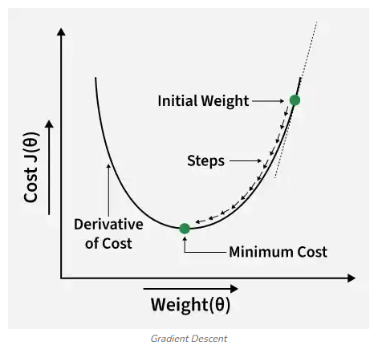
How it works:
Start with random values from slope and intercept.
Calculate the error between predicted and actual value.
Find how much each parameter contributes to the error (gradient).
Update the parameters in the direction that reduce the error.
Repeat until the error is as small as possible.
This helps model find the best- fit line for the data.

